Name:____________________________________________ Date:________________ Period: _______

HW Quiz (10 Points)

Show work to support your answer for full credit and include UNITS in your answer.

Suppose 1 dip = 4 bop, 1 bop = 8 dab, 13 tick = 1 tock, and 2 tock = 5 rip.

Convert 28 $\frac{dip^{2}}{rip}$ into $\frac{bop^{2}}{tock}$

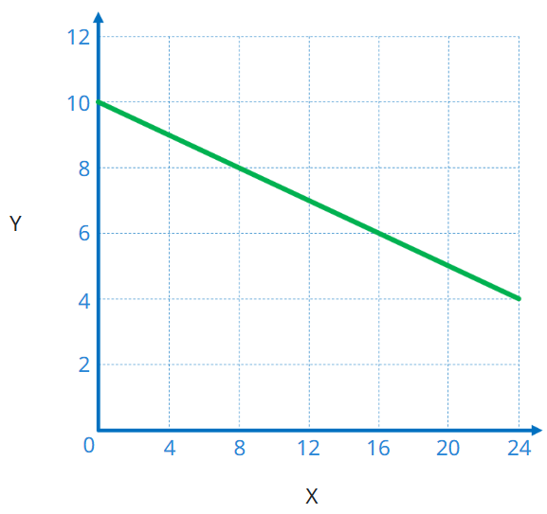
Use the graph to answer the following questions:
- What is the slope of the line?
(Write in decimal form)

- What is the area under the graph?

HW Quiz – Make-up (10 Points)

Show work to support your answer for full credit and include UNITS in your answer.

Suppose 1 dip = 4 bop, 1 bop = 8 dab, 13 tick = 1 tock, and 2 tock = 5 rip.

Convert 62 $\frac{dip}{rip^{2}}$ into $\frac{bop}{tock^{2}}$

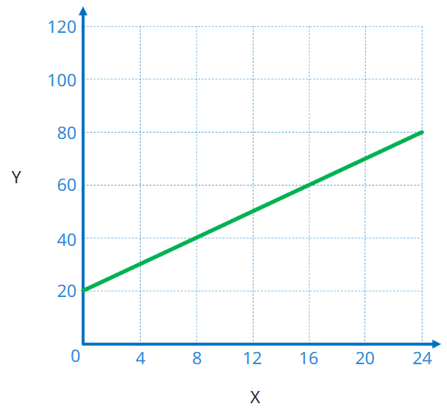

Use the graph to answer the following questions:
- What is the slope of the line?
(Write in decimal form)

- What is the area under the graph?

